Home page

1

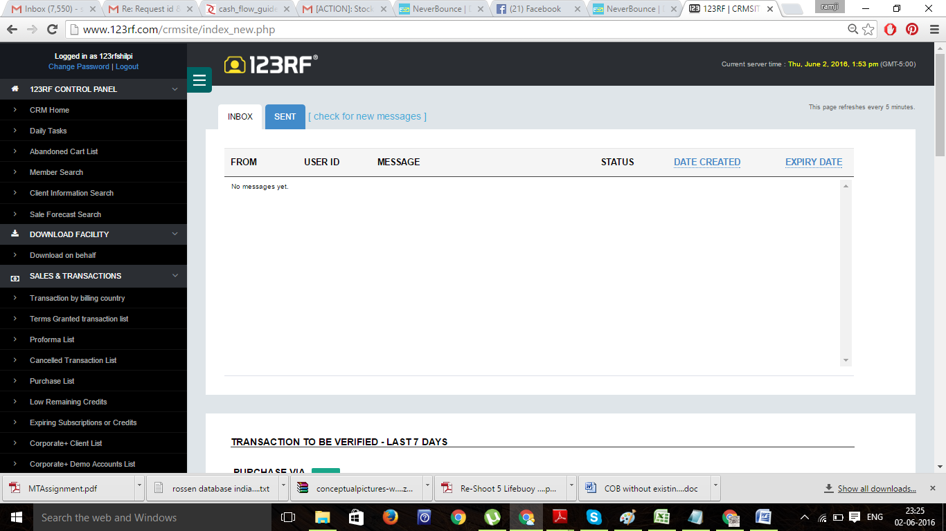

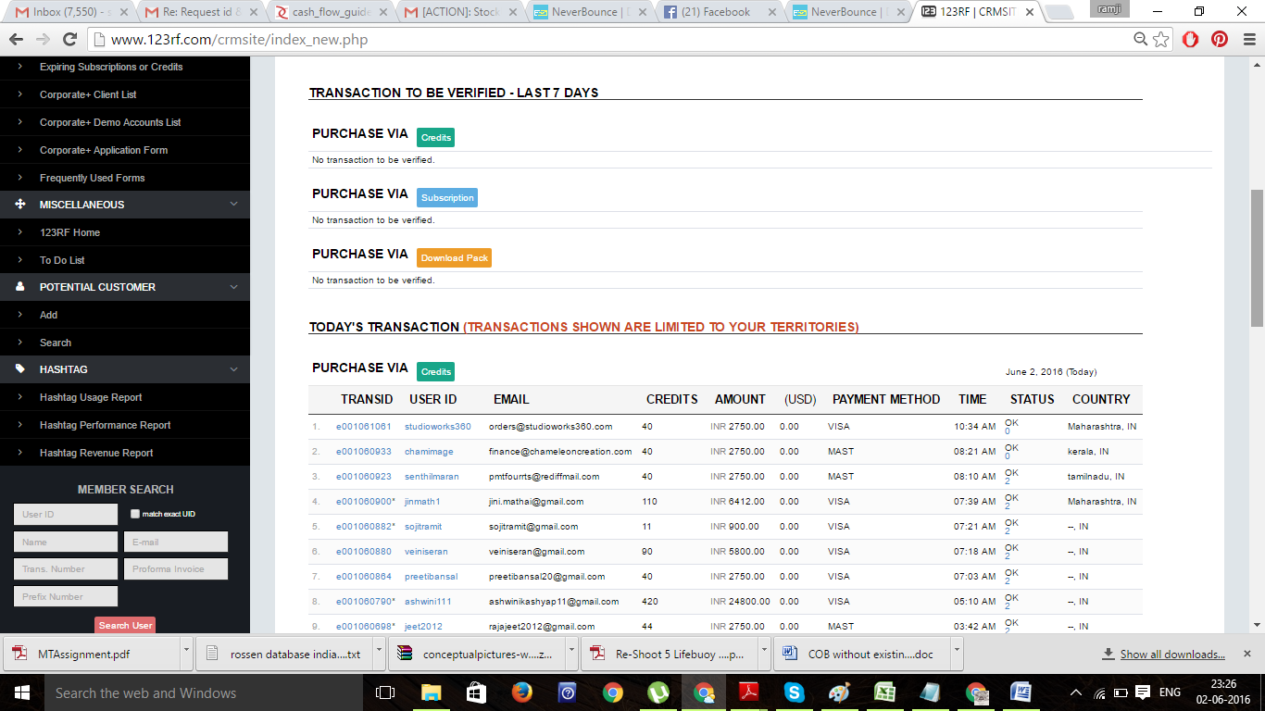

Daily Task

2

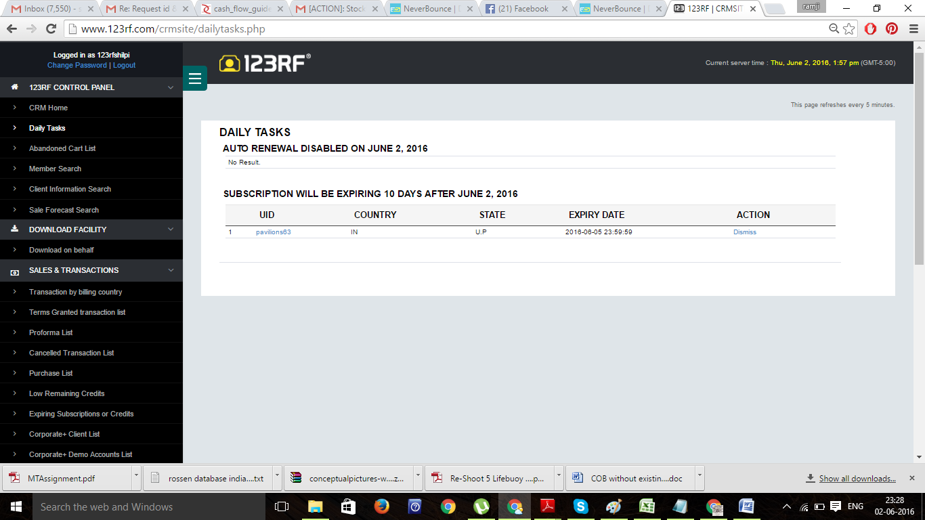

3

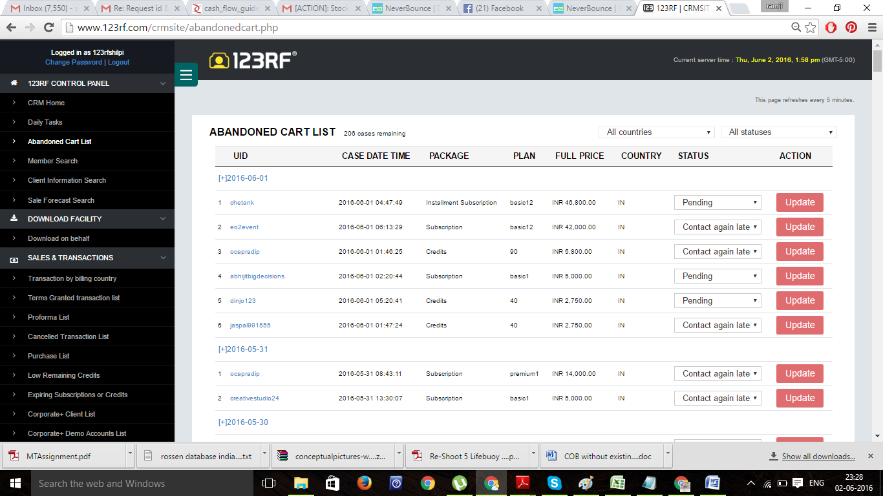

Member search

4

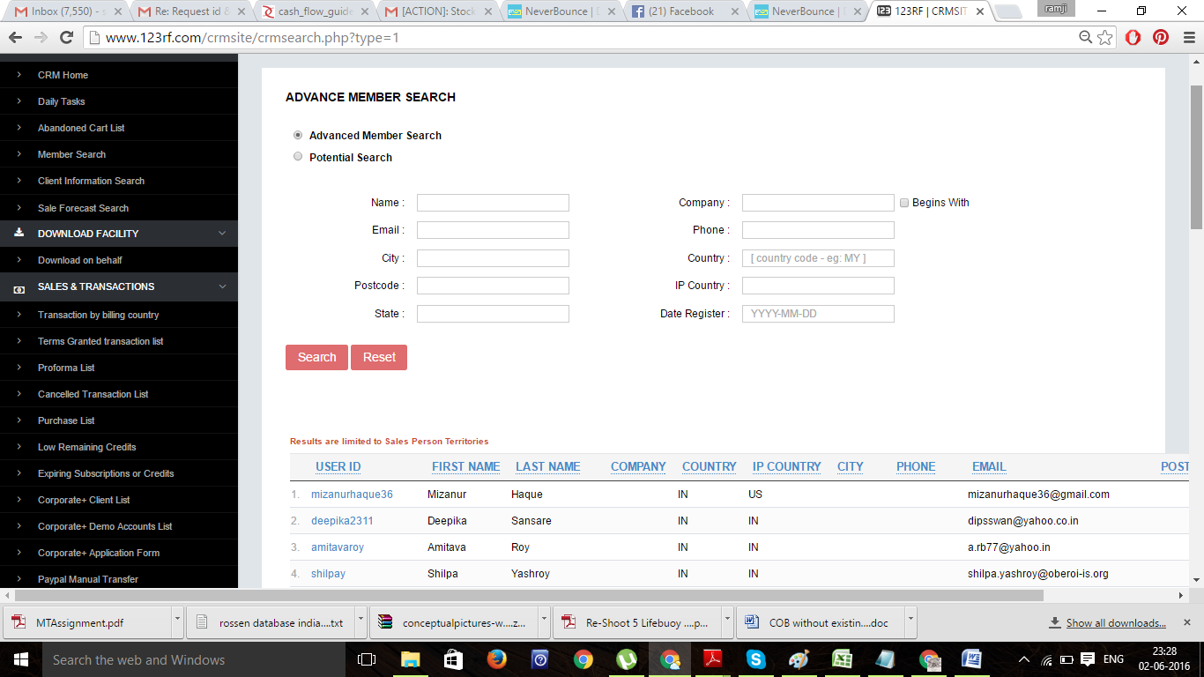

Search client information-4

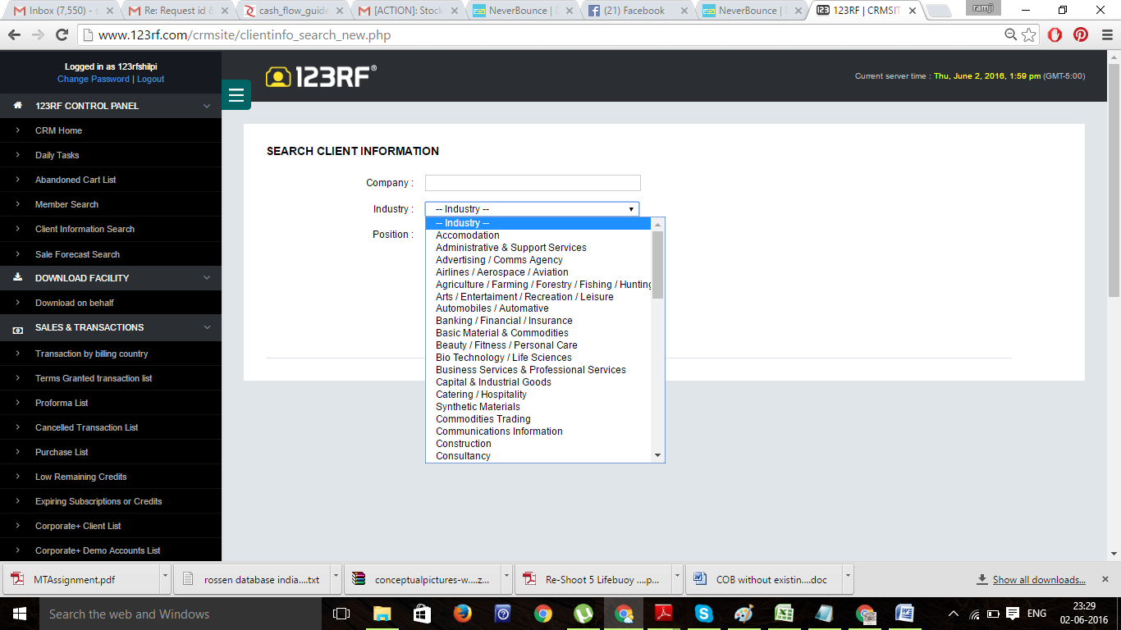

Sales forecat search

5

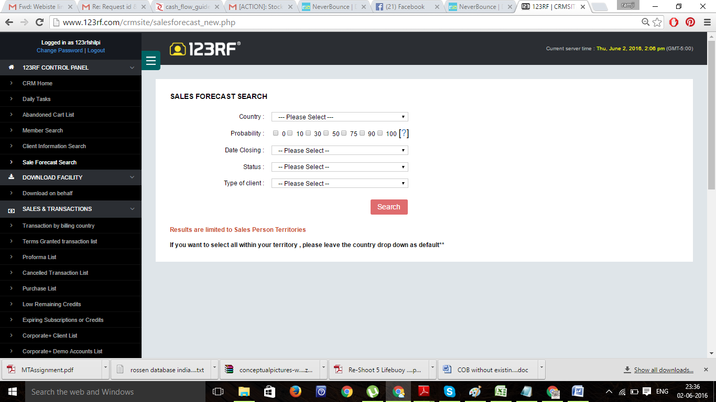

Download on behalf- 6

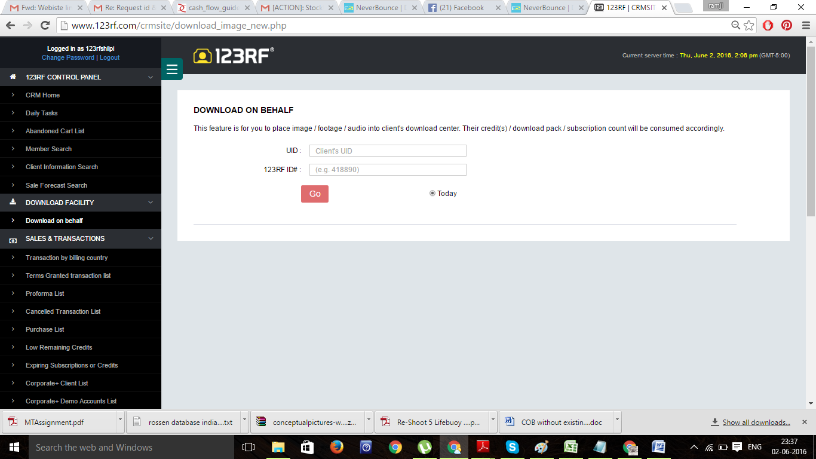

Transaction search : usually 100 items appear on 1 page

7

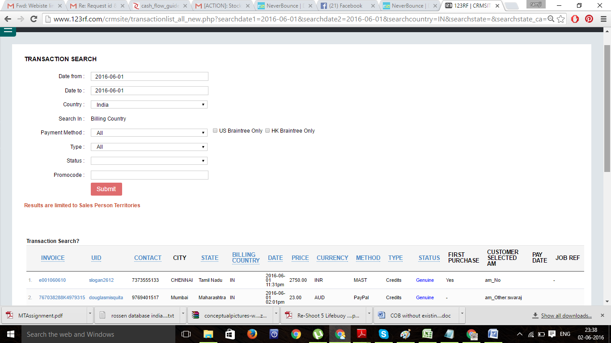

Proforma list- 8

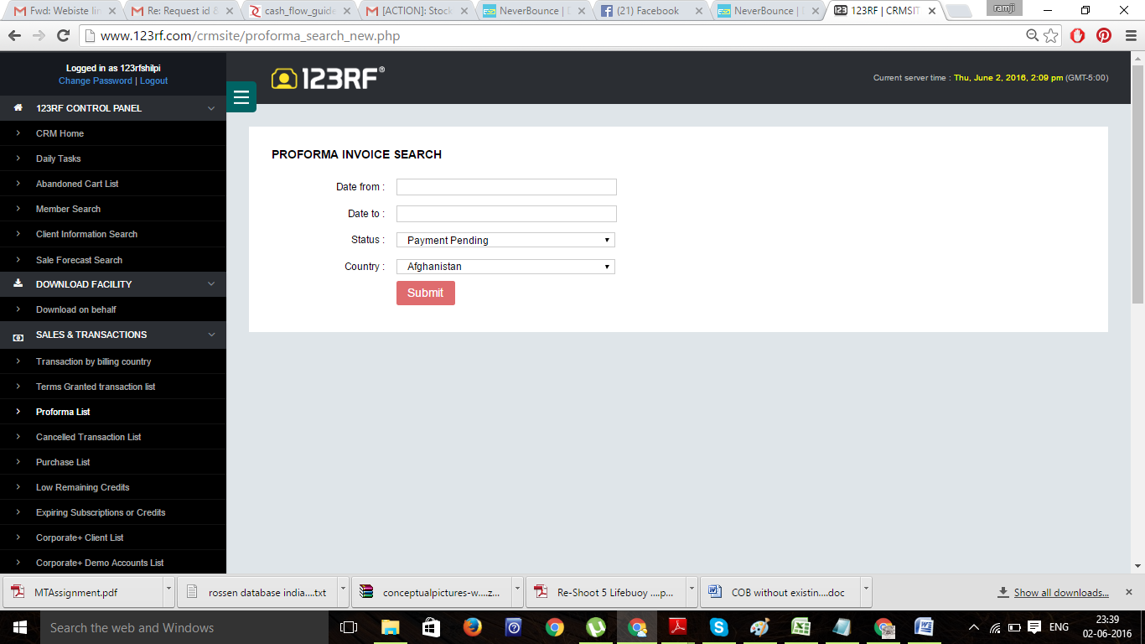

cancelled transaction- 9

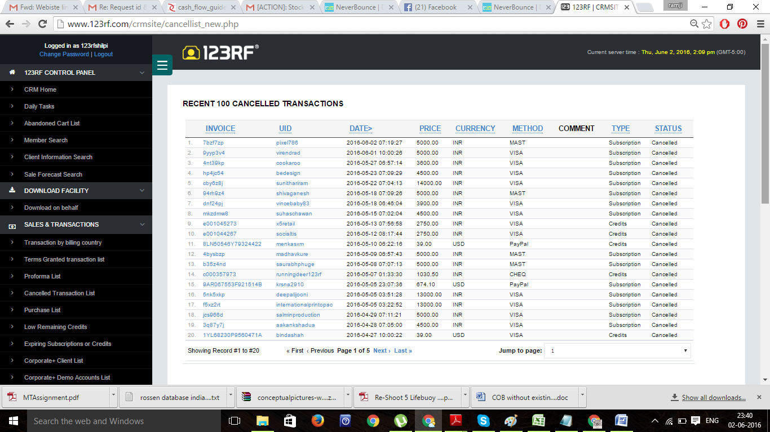

Low remaining credit list- 10

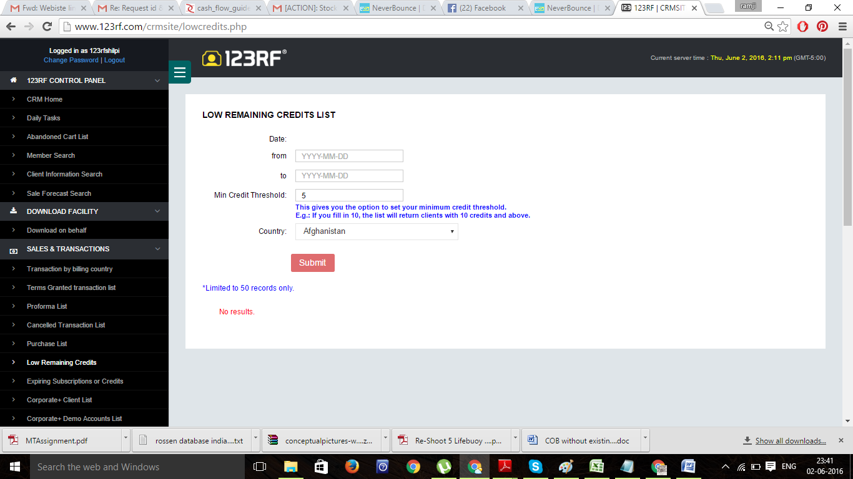

expiring subscription- 11



Paypal manual transfer- 12

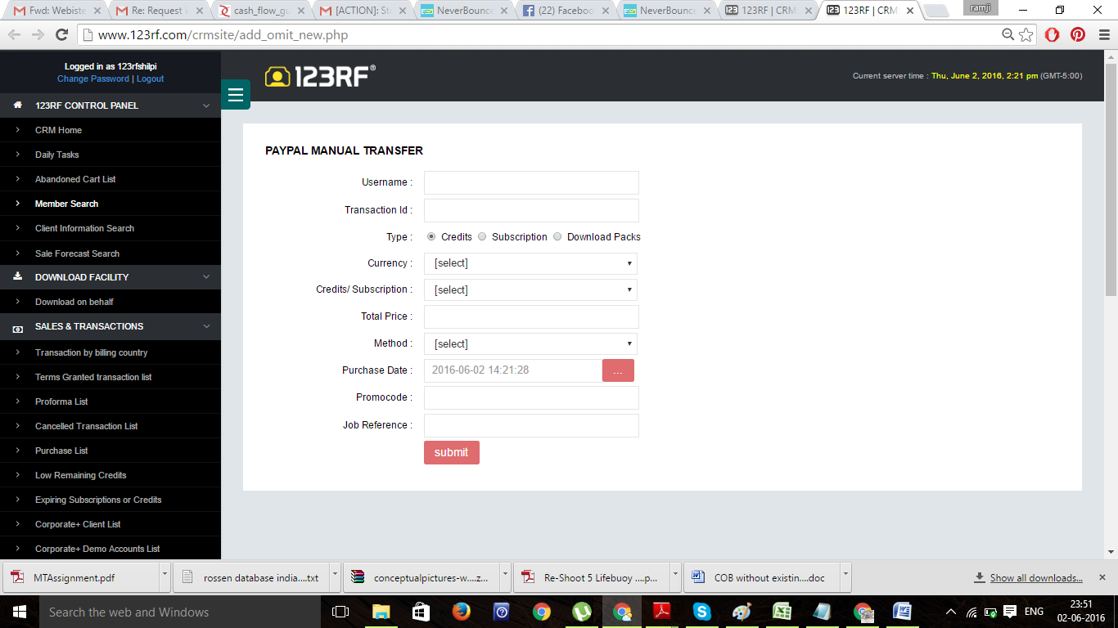

Member search- 13

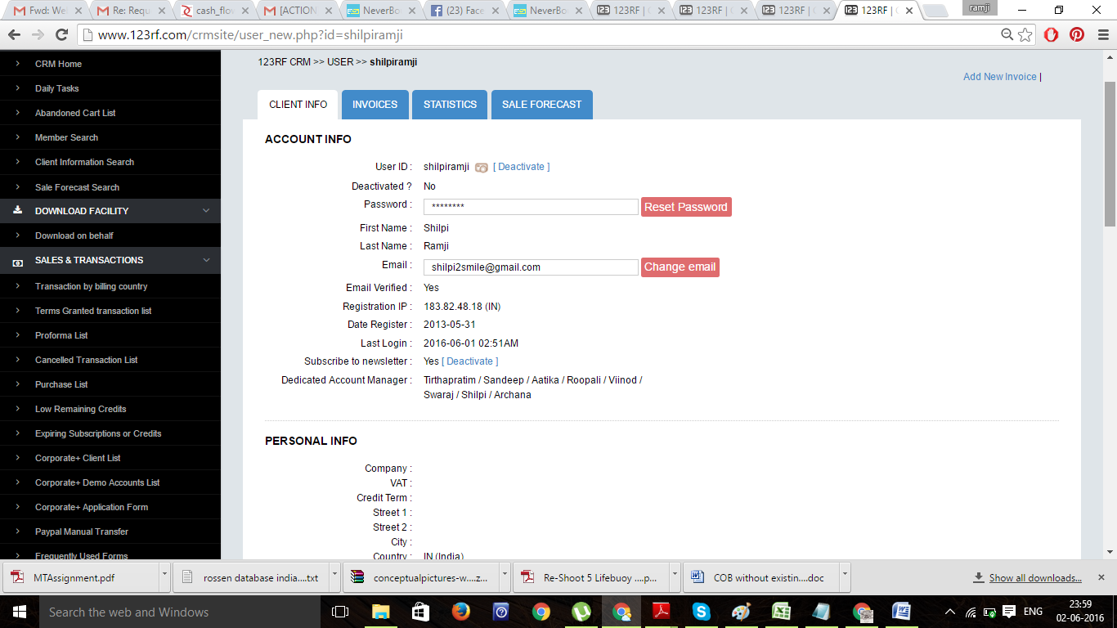

14

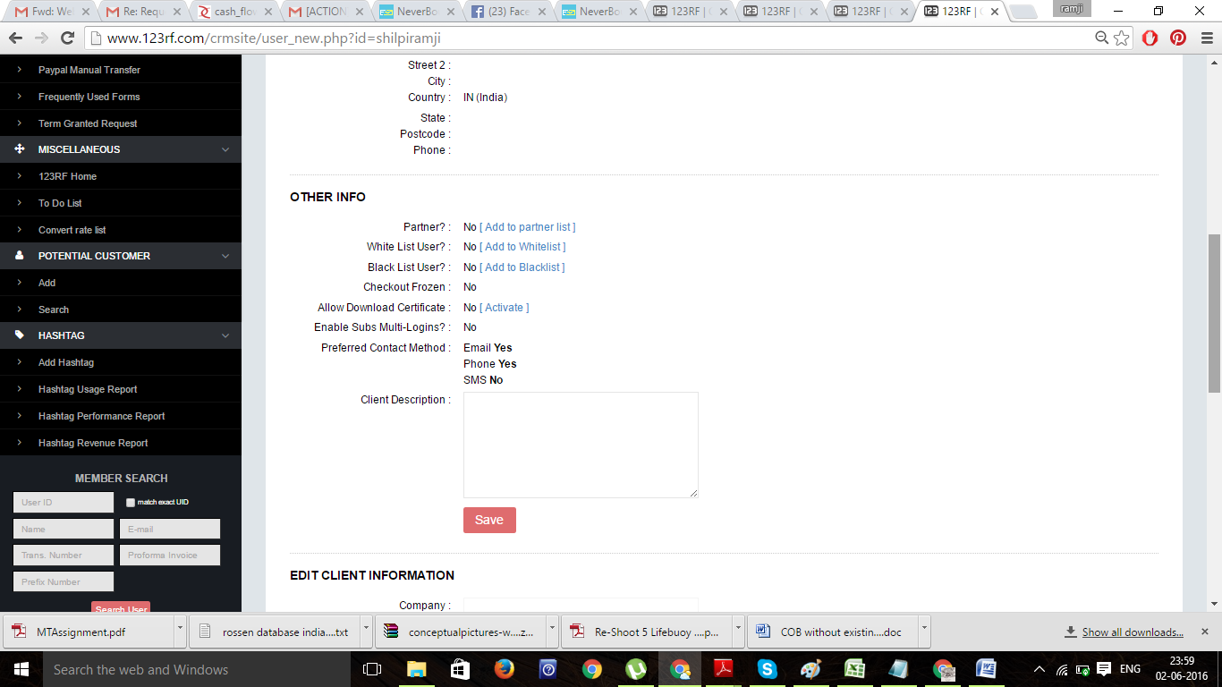

15

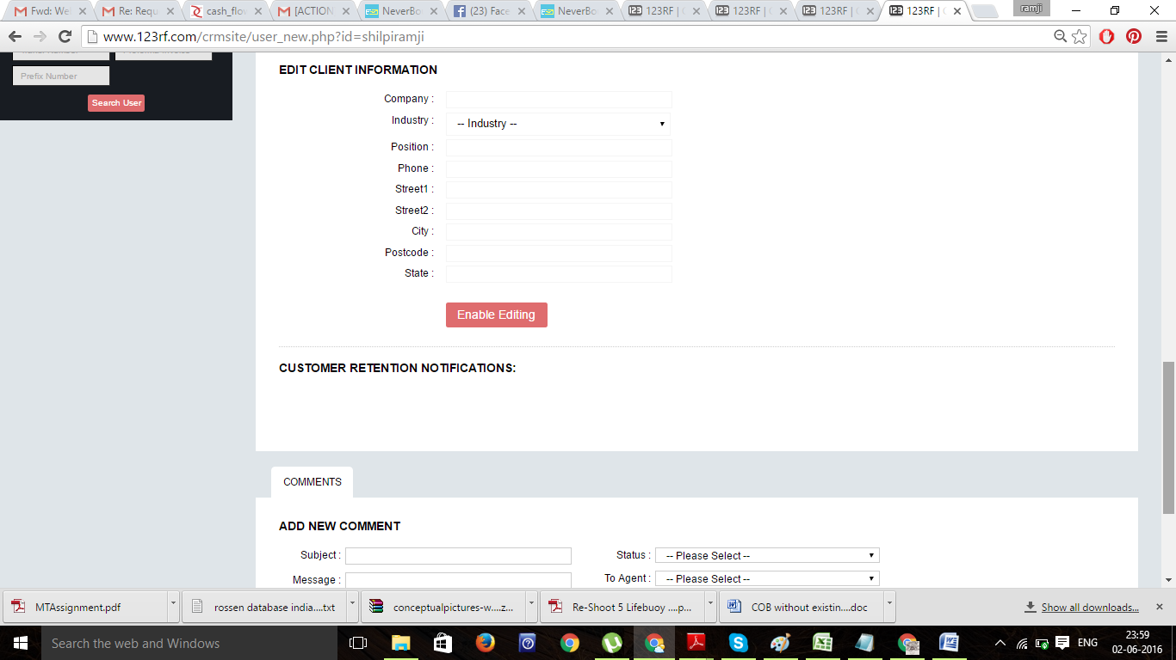

16

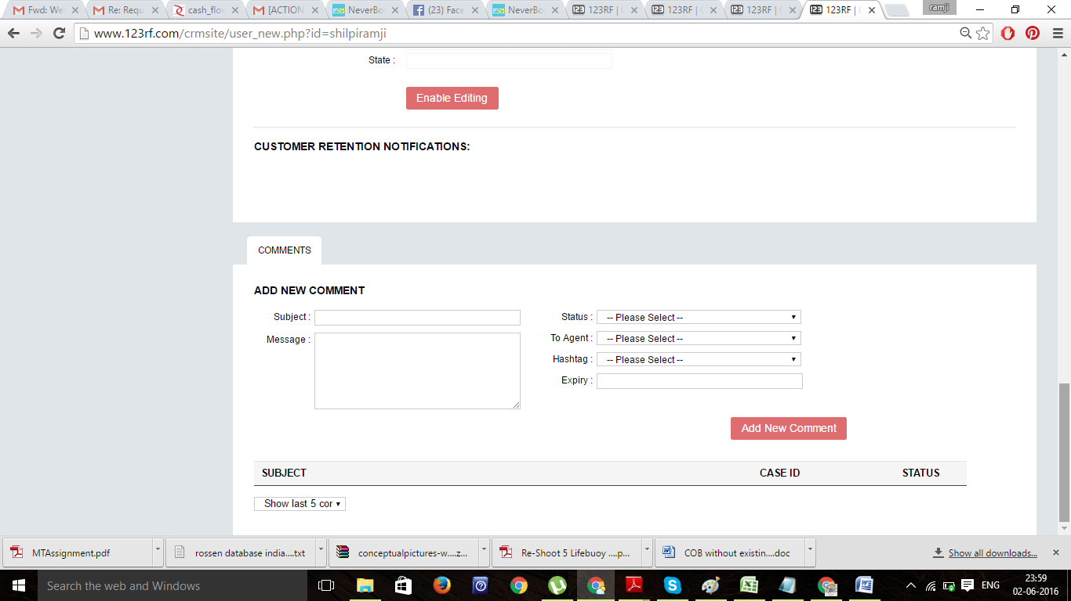

17

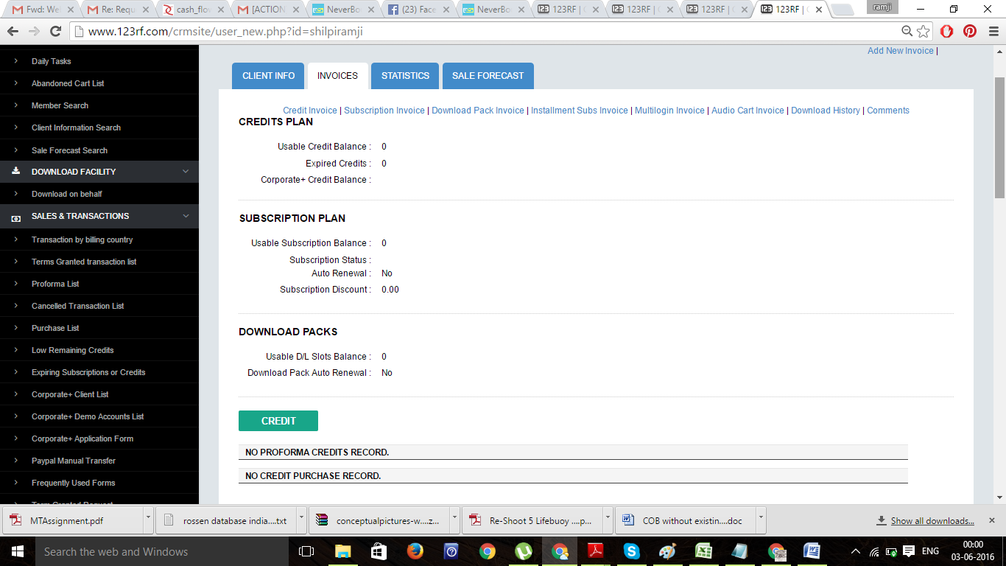

18

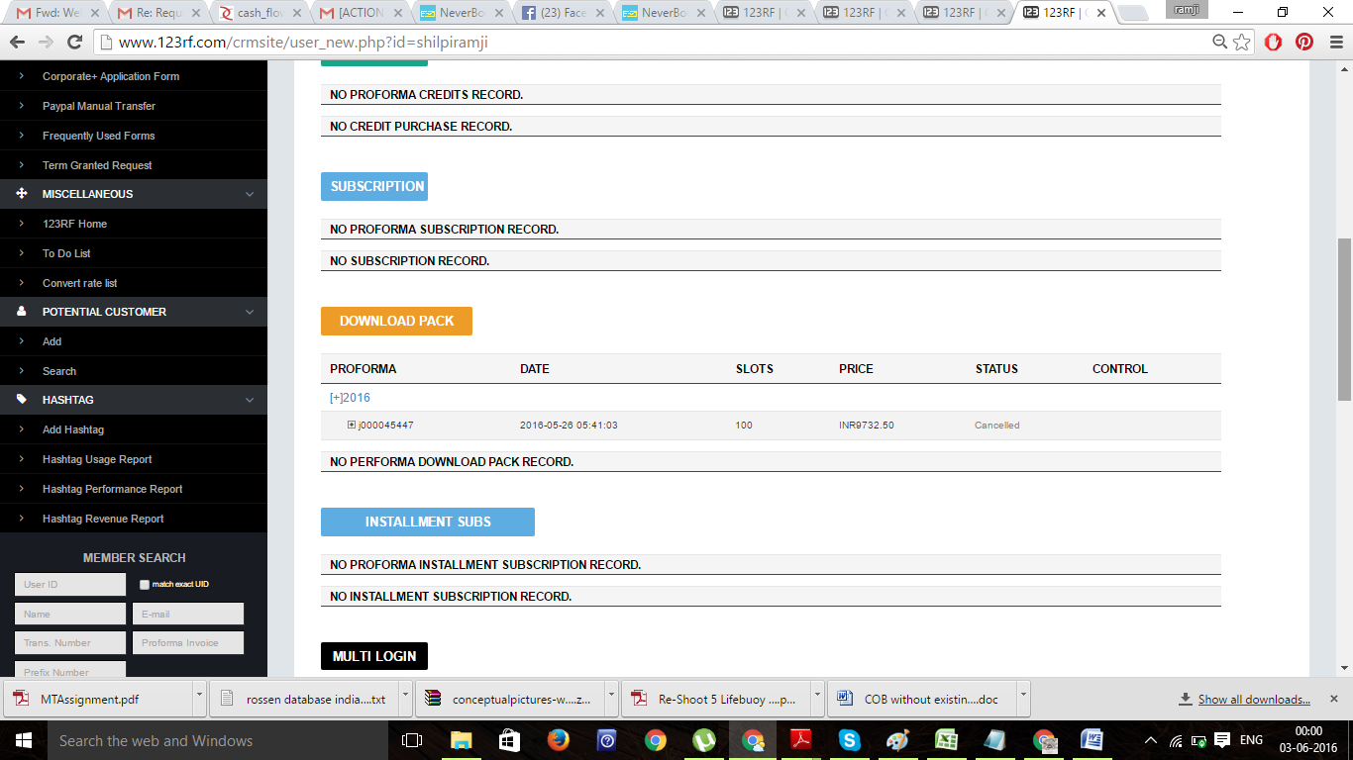

19

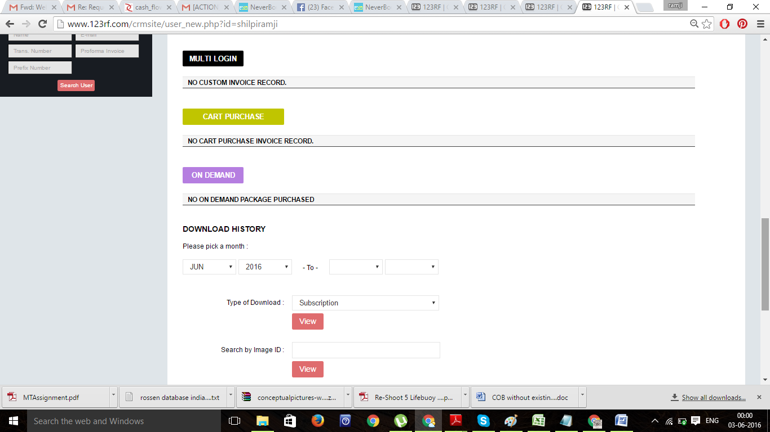

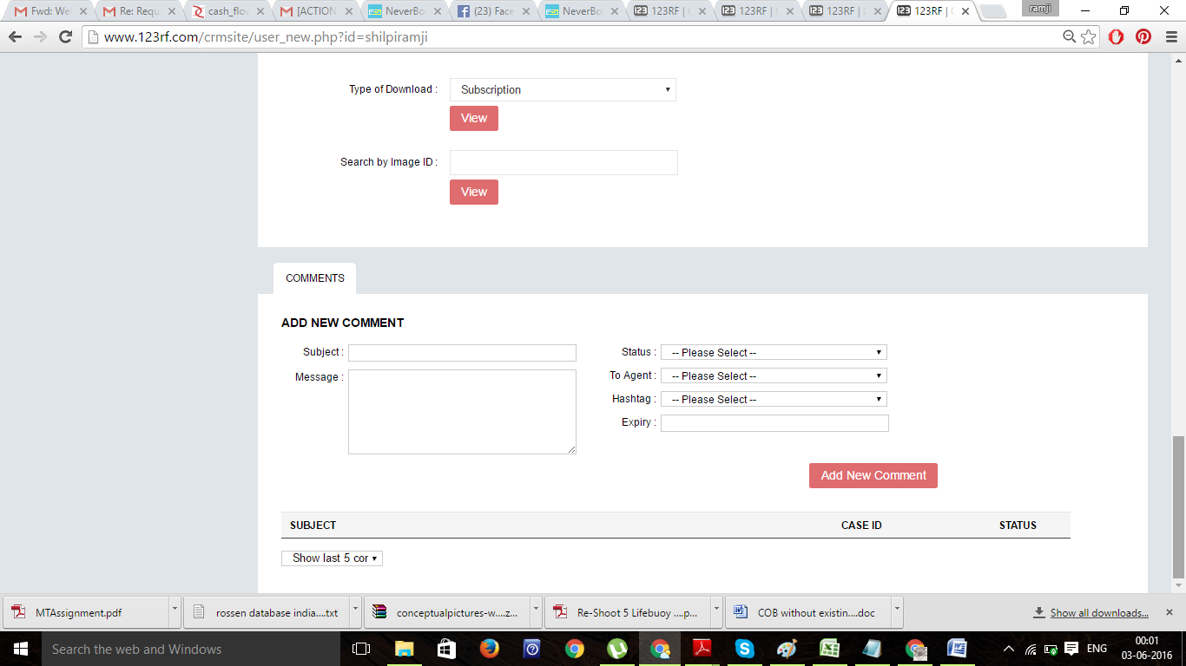

20

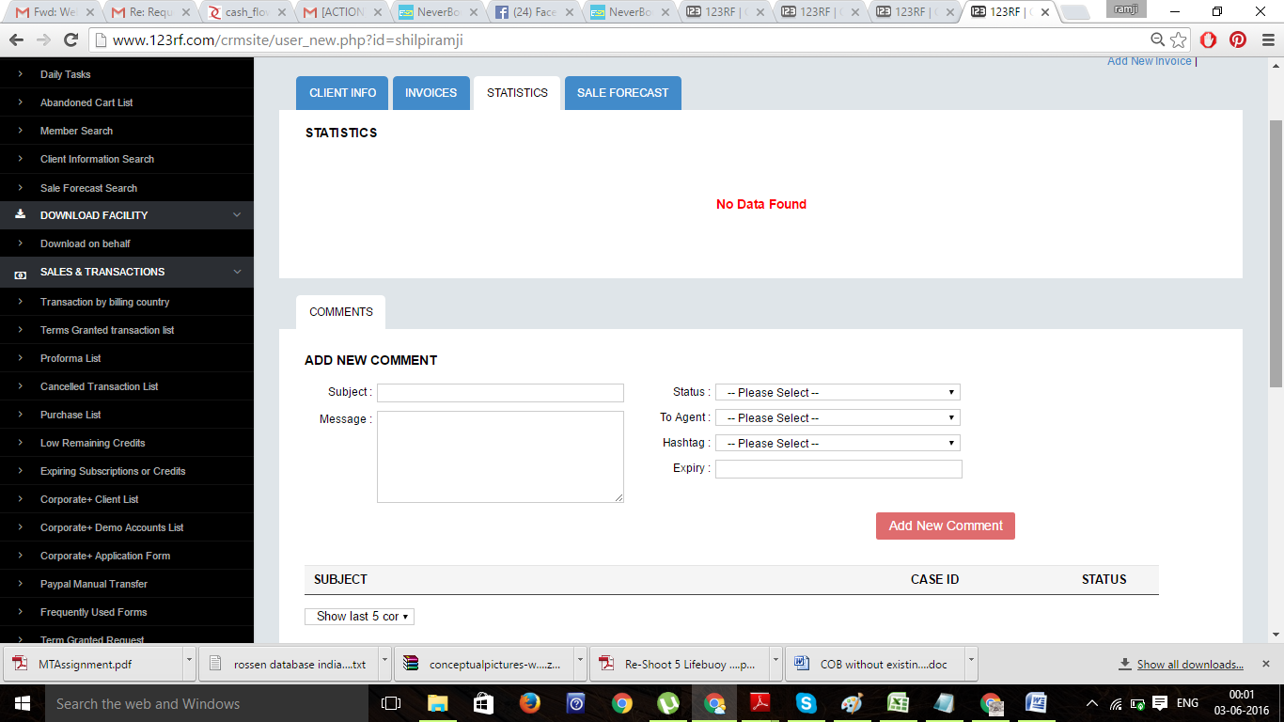

21

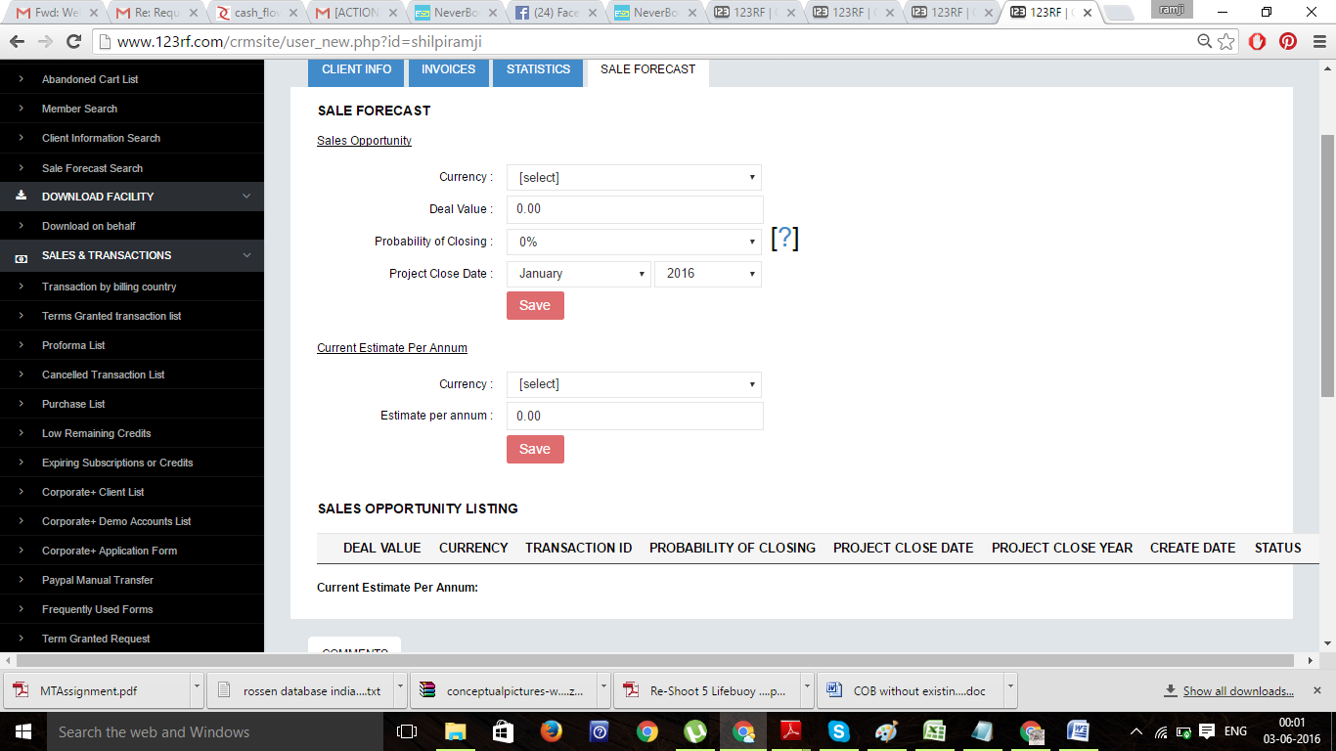

We should also have option to create Client account in the CRM.

These CRM will be operated by various Client servicing team and accounts team with their Individual User IDs and passwords.

Once client goes into a client’s account, they are able to create Invoice, initially Proforma Invoice( PI)/ Quotation and then once it is approved, the status of the PI has to be manually changed to complete, when another Tax Invoice gets generated with another unique serial number and both of these invoice/Quotations are available online.

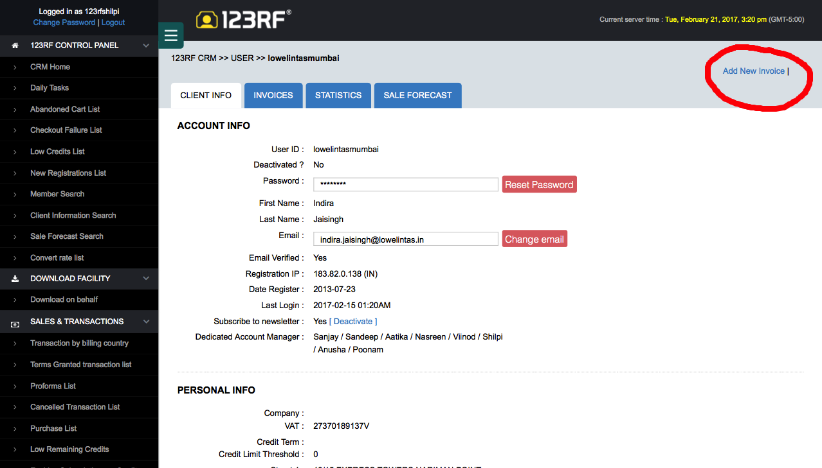

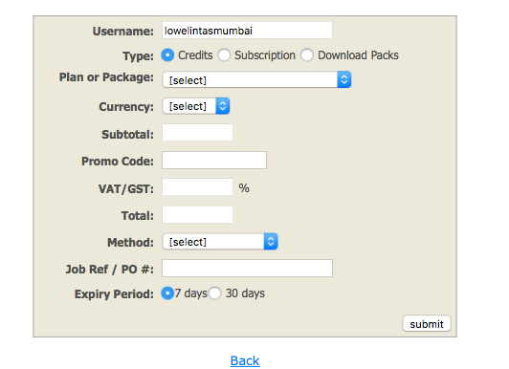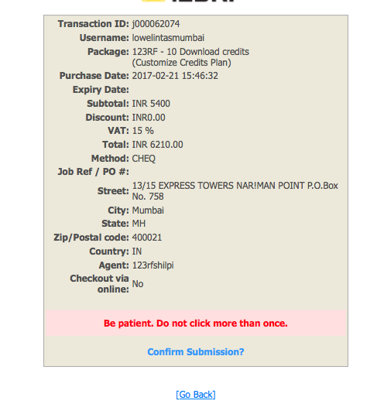

Now what we need here is little customisation. On top under **TYPE** we need another field **Images,** If you select images, then Under Images, No of Images, Image Nos(unique no of individual image), Image upload option, size should be the smallest ,Against image nos; RM/RF in dropdown and sizes in dropdown and cost of each image

Then Sub Total, Promo code etc as above.

Under RM images we need a lot of License Details that needs to be captured on the Invoice, hence please follow the below link to create those fields.

http://www.masterfile.com/search/enlarged_pricing.html?img=700-06961979

Performa Invoice/ Quote Sample as below

Invoice Sample



Proforma Invoice/ Quotation sample with Images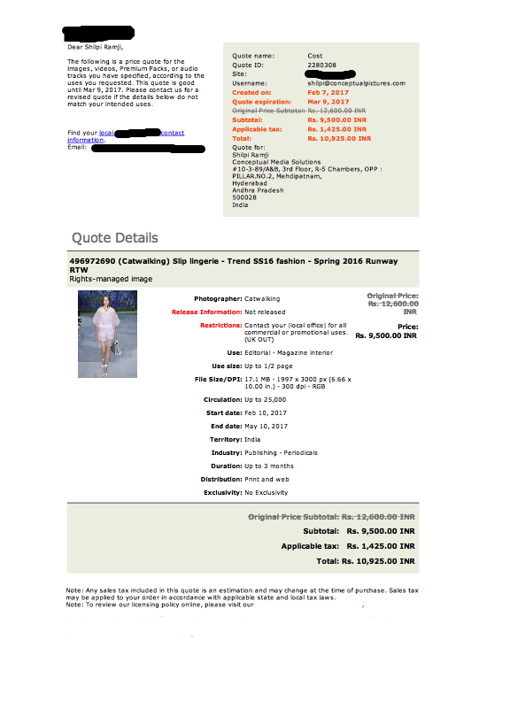

Sample Tax Invoice with Images

